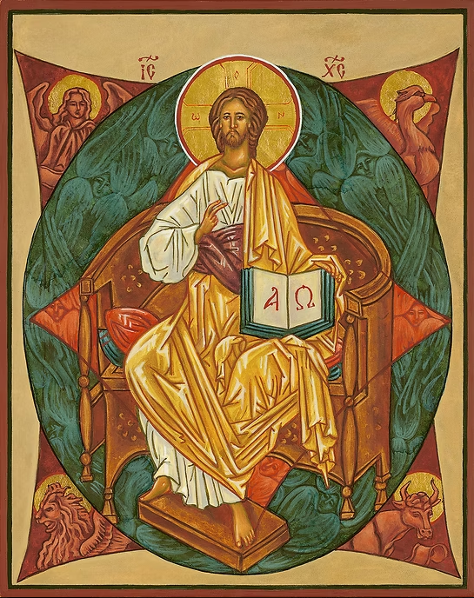
Christ in Majesty

The icon Christ in Majesty or Christ in Glory was first written by St. Andrei Rublev in 1408. It is a very popular image that has been depicted both in icons and in western art styles.
In the icon, Jesus sits enthroned with a book open. The symbols for alpha and omega can be seen in the book, which represent Christ’s titles as the beginning and end of all things. He is enrobed in gold and red. The gold around him represents His divinity and the red represents His martyrdom. The white peaking out on His robe between the other clothes demonstrates His purity.
He has a cruciform halo around His head with the shape of a cross inscribed into it to remind us of His crucifixion. In the cruciform halo, three Greek letters spell the name of God, “He Who Is,” in reference to the name of God given to Moses, “I Am.” The outline of His halo has a red and white line: these again represent Jesus’ Alpha and Omega titles.
In a green circle around the image of Christ are seraphim. They are the hierarchy of angels that circle God’s throne, continually giving Him praise and are mentioned in Isaiah 6:2-7. To cover their feet and faces in the presence of God, they are described as having six wings. The final images are the tetramorph in the four corners of the icon. The four winged creatures, known as the tetramorph, represent the four evangelists who wrote the gospels: a man with wings stands for Matthew, a bird stands for John, a lion with wings stands for Mark, and a bull with wings stands for Luke. Above the main part of the icon, “IC XC” is written, because it is the Greek abbreviation for Jesus Christ. The gold that pervades the whole background is a representation of Jesus’ heavenly existence.

