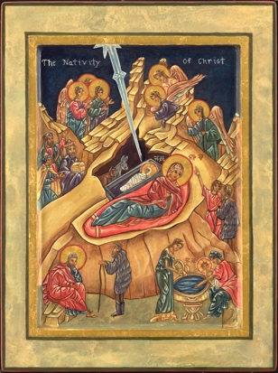

The Nativity

This icon is not captive of a single moment in time. Instead, it shows events that happen both before and after the birth of Christ. For example, the journey of the wise men and the midwives washing the newborn child. As traditional in iconography, the main event is moved to the foreground, free of its surroundings, so the cave is placed behind, rather than around Mary and her child. The black of this cave represents all human disbelief, all fear, and all hopelessness. The austere mountains suggest a hard-unwelcoming world. The donkey and ox show that Christ was for all creatures, great and small. Shooting down towards the child, the star ray represents the Trinity – God at the top, the Holy Spirit in the center, and, of course, Christ.
Christ’s swaddling clothes are similar to that of Christ’s burial cloths. The manger is meant to look like a coffin: linking His birth to His death. We bear our death within us from the moment of birth. Our life is one piece, and its length is much less important than it’s purity and truthfulness.
Mary is framed by the red blanket and resting on red: the color of life, but also the color of blood. She is reclining, resting after labor, having completed this stage of her struggle. However, Joseph still grapples with his. In the icon’s lower left-hand corner, we find a troubled Joseph confronted by a figure (most often a bent old man), who represents “the voice of unenlightened reason” (his doubts about the miracle). To the right of Joseph, the midwives washing the child Jesus is also representative of His humanity.

