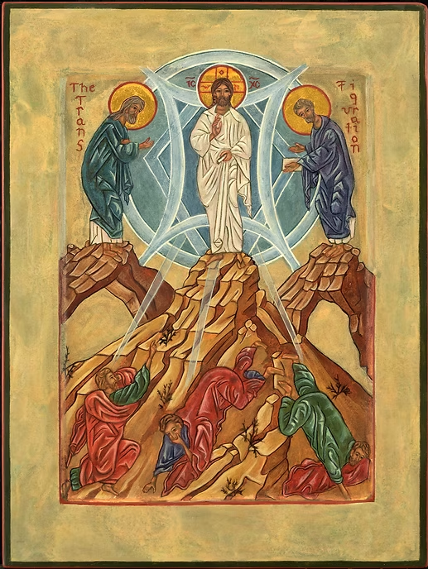
The Transfiguration
In the Synoptic Gospels–Matthew, Mark, and Luke–the story of the Transfiguration is told. Jesus took Peter, James, and John up to a mountain. On this mountain, Jesus allowed His divinity to be shown in the form of blinding light. Also, Moses and Elijah appeared and conversed with Him. Peter said that they should build three tents for Jesus, Moses, and Elijah after seeing this great miracle. Then, the voice of God reiterated that he was pleased with His son, Jesus, and the three apostles became afraid. Finally, when they looked up again, it was only Jesus as He appeared in human form. They were charged not to tell anyone about this until after the resurrection.
In the icon, Jesus stands at the top of the mountain, as He did in the Biblical story with Moses and Elijah. Around Jesus’ head is a cruciform halo to remind the viewer of the crucifixion. Within the halo are the letters, “W O N,” meaning, “The One Who Is” in reference to the name of God revealed to Moses, “I Am.” Around the halo are red and white lines, standing for the titles of God as Alpha and Omega, the beginning and end of all things. On either side of the halo, the letters “IC XC” stand for the name Jesus Christ. The blue halo around His body denotes the glow of His divinity, and Peter, James, and John lie prostrate below Him.

